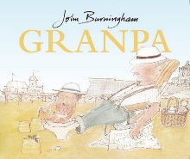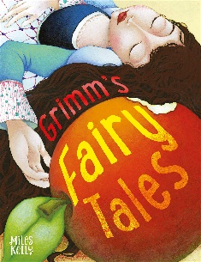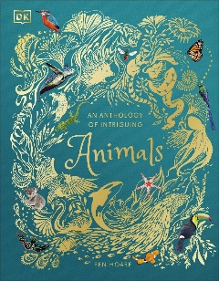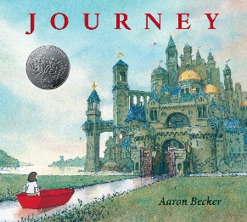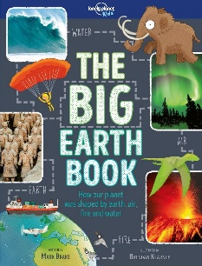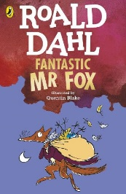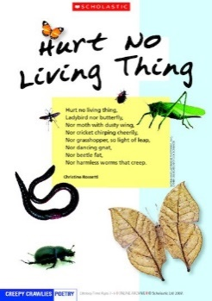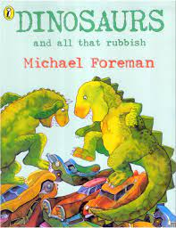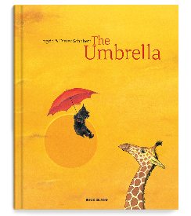

**Talk for Reading**

**Science**

* Throughout the year – Working scientifically
* Autumn 1 – Properties of materials
* Spring 2 – Living, dead or never alive

Survival

Offspring

Food chains

Habitats

Diet, exercise and hygiene

* Summer 1 – Plants
* Summer 2 – Properties of materials

Changing materials

**Maths**

* Autumn 1 – Place value

Addition and subtraction

* Autumn 2 – Multiplication and division

Length

* Spring 1 – Pictograms

Temperature

Mass

* Spring 2 – Money

Fractions

Time

* Summer 1 – 2D & 3D shapes

Volume

* Summer 2 – Recap of units

**Talk for Writing**

* Autumn 1 – ‘Journey’ tales
* Autumn 2 – Non-chronological reports

Poetry

* Spring 1 – ‘Tales of Fear’
* Spring 2 – Instructions
* Summer 1 – ‘Meeting’ tales
* Summer 2 – ‘Beat the Baddie’ tales

Poetry

**RE**

* Autumn 1 – Being Human – Islam (Believing)
* Autumn 2 – Life journey – Islam (Living)
* Spring 1 – Thankfulness (Believing, Living,

Thinking)

* Spring 2 – Thankfulness (Believing, Living,

Thinking)

* Summer 1 – Salvation – Why does Easter

matter to Christians?

* Summer 2 – Incarnation – Why does

Christmas matter to Christians?

**Geography**

* Autumn 1 – Continents and oceans

Climate change

* Spring 1 – Non-European locality (India)
* Summer 2 – Sleaford and Hunstanton

**Year 2**

**Music**

* Autumn 1 – Pitch, dynamics and tempo

Pulse and rhythm

Introduction to graphic symbols

Bach, Mozart, Chopin, Elton John

* Autumn 2 – Stick notation

Copycat rhythms

Tchaikovsky, Edward Elgar,

Florence Price, David Bowie

* Spring 1 – Call and response

Dot and stick notation

Carnival of the Animals

World Music

* Spring 2 – Cup percussion and boomwhackers

World Music

* Summer 1 – Ocarinas and drumming

Gospel, Vivaldi, Clara Schumann,

Paul Simon, Ella Fitzgerald

* Summer 2 – Ocarinas, keyboards and ukeleles

Verdi, Rossini, Louise Farrenc,

Brian Wilson

**Design Technology**

* Autumn 2 – Wheeled vehicles

Computed-aided design

* Spring 2 – Garden and playground structures
* Summer 1 – Garden and playground structures (continued)

**Computing**

* Autumn – Online Safety

Effective Searching

Creating Pictures

* Spring – Making Music

Questioning

Coding

* Summer – Spreadsheets

Presenting Ideas

**PE**

* Autumn 1 – Athletics and Dance
* Autumn 2 – Games and Dance
* Spring 1 – Games and Yoga
* Spring 2 – Games and Gymnastics
* Summer 1 – Games and Gymnastics
* Summer 2 – Games and Gymnastics

**French**

* Autumn – Numbers and colours
* Spring – Classroom instructions

Familiar stories

* Summer – Months and birthdays

Adjectives

**History**

* Autumn 1 – Famous Britons
* Autumn 2 – The Gunpowder Plot

The Plague

The Great Fire of London

**Art**

* Autumn 1 – Painting
* Spring 1 – Batik

Sewing

* Summer 2 – Sculpture