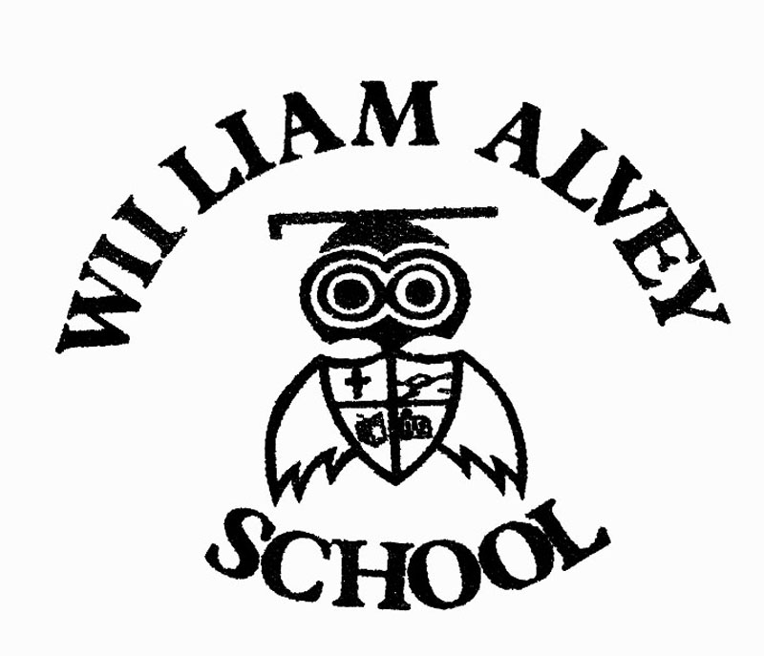 | Parent Feedback
Name: | Date:
Comments:

Please complete and send to the school office or e-mail as an attachment to:
admin@william-alvey.lincs.sch.uk

