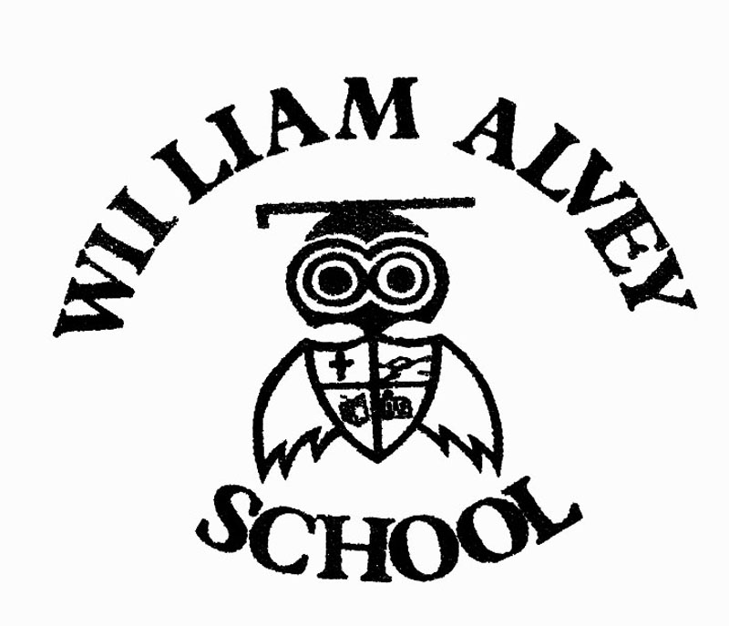 Bullying and prejudice related incidents report form

Section 1: Staff details
Date:
Name of staff:
Email address of staff:
After completion this form needs to be handed to: Mr Stephen Tapley (Head Teacher).

Section 2: Details of incident
If you are unsure of the category (for example whether it is homophobic or biphobic bullying) then you can tick all that you think may apply and simply explain the details.
 | Bullying |  |  |  | Prejudice related incident
Nature of incident: Tick all that apply |  |  |  | Form of bullying or incident: Tick all that apply
 |  | Physical (e.g. hitting, kicking, pushing or inappropriate/unwanted physical contact |  |  |  | Race-racist bullying
 |  | Verbal (e.g. name calling, ridicule, comments) |  |  |  | Sexual orientation-homophobic
 |  | Cyber (e.g. messaging, social media, email) |  |  |  | Sexual orientation-biphobic
 |  | Emotional/indirect/segregation (e.g. excluding someone, spreading rumours) |  |  |  | Special educational needs (SEND) or disability
 |  | Visual/written (e.g. graffiti, gestures, wearing racist insignia) |  |  |  | Culture or class
 |  | Damage to personal property |  |  |  | Gender identity-transphobic
 |  | Threat with a weapon |  |  |  | Gender-sexist bullying
 |  | Theft or extortion |  |  |  | Appearance or health condition
 |  | Persistent bullying |  |  |  | Religion or belief related
 |  | Other |  |  |  | Related to home or other personal circumstances
 |  |  |  |  |  | Other or non-specific

Details of those involved, whether adults, pupils, visitors from the school community and from external organisations.
 | Names: | Age/year group | Form/tutor group | Other relevant information (e.g. gender, SEND, disability, religion)
Target of bullying/incident

Person responsible for bullying/incident

Details of incident
Date |  | Place |  | Time
Witnesses

Repeat incident or serious incident
Any relevant supporting information e.g. witness accounts/screen grabs
Action taken

Details of others involved or notified

Actions for follow-up

Date for reviewing

