Jenny Clifford NKDC Awards

Earlier this year we welcomed a family of four children from Afghanistan. The children quite understandably were scared and clearly traumatised. The children hadn’t been to school before and could not speak English.
The family arrived with very few belongings, they left on a plane similar to the ones seen on the news footage. Jenny organised a range of support for the family. She initially asked staff to provide clothes and toys. She got Dad to record some messages in Pashto, for the children to make them feel happier in school (Lunch soon/Dad will come and collect you later/You are safe).
Jenny then contacted a number of agencies including EMTET (Ethnic Minority and Traveller Education Team) to organise educational support. She didn’t leave it there either. She started a lunch time club for all four children and subsequently a little boy who joined us from the Ukraine.
Jenny then applied to be a refugee welcome school:
Dear Jenny,
Thank you for submitting an application for William Alvey Primary School to become a Refugee Welcome School.
Our panel, including experts from NASUWT, Citizens UK, the Institute of Education and with lived experience of the immigration system met last month to consider your application, and I am very happy to tell you that your school has been accredited as a Refugee Welcome School.
The panel felt that your welcome plan was exceptional, with well-thought through systems and evidence of what does and doesn't work.
The panel also found your awareness plan was exceptional - especially the support for teachers collectively. They encouraged you to go even further and consider a plan of awareness for parents and the wider community.
They also found your action plan exceptional - it would be good to set up a conversation about the best way your school can engage with your local MP on welcome - I can support with ideas for this.
Overall the panel felt that the application more than met the assessment criteria with an exceptional application and so I am very happy to tell you that William Alvey Primary School has been accredited as a Refugee Welcome School. Congratulations to you all!
Best wishes,
Jess
Tel. 07954 143704
jessica.maddocks@citizensuk.org
www.citizensuk.org | @CitizensUK | facebook.com/CitizensUK
Join our mailing list | Donate to support our work

The children have settled in brilliantly, their Dad has a job and says the children are the happiest they have ever been.

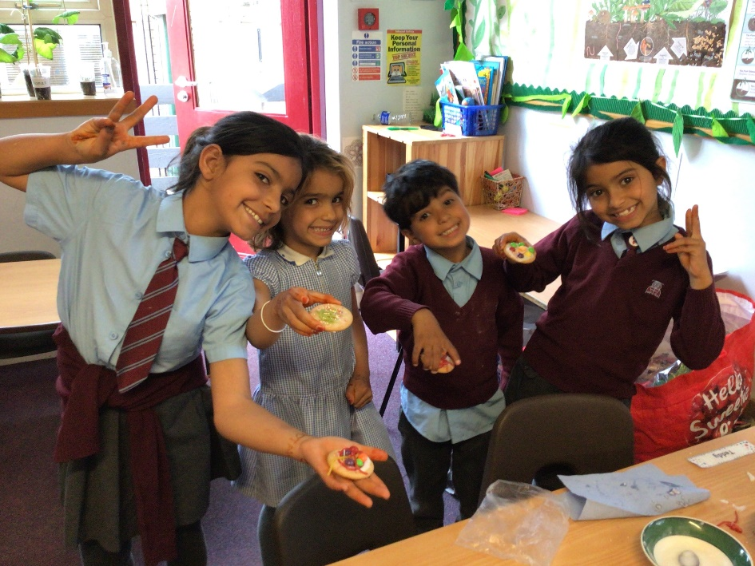

Carrying on with support she offered the children from Afghanistan, after the outbreak of war in the Ukraine, Jenny organised a collection for the Ukraine:

As well as the items on the first list, clothes will now also be gratefully received. Please continue to bring them into school and Mrs Clifford will deliver them. She has already delivered a car full of generous donations from the parents at the Alvey. She was so impressed with the work they were doing when she dropped them off. If any parents would like to volunteer their time at the central donation sorting and packing station in Lincoln, please email Jenny.Clifford@william-alvey.lincs.sch.uk for details.

Jenny then decided to deliver our donations to Lincoln:

Hello,

I am going to move all of the generous donations into the hall tomorrow in prep for the portacabin to be removed. There is so much more than I first thought and my conservatory is already filled with donations too! I am volunteering at the centre on Monday and taking in donations, but I can't fit it all in my little car. The drop off point is at the old Sofology shop in St Mark's shopping in Lincoln. Just wondered if anyone is going to Lincoln on Monday, would they mind dropping some off too please? You can take from the hall now or on Monday morning. I'll be in school at 9 am on Monday to pack up my car and can help you carry bits to your car as well.
Sofology warehouse will not open until 10am and drop offs are by arrangement only, so it has to be Monday I'm afraid, as that's when I've booked our donations in.
Thank you.
Jen
Get Outlook for iOS

And after dropping off our donations, she started volunteering at the warehouse herself and offered them the school’s fund raising support:

PTA Bags2chool

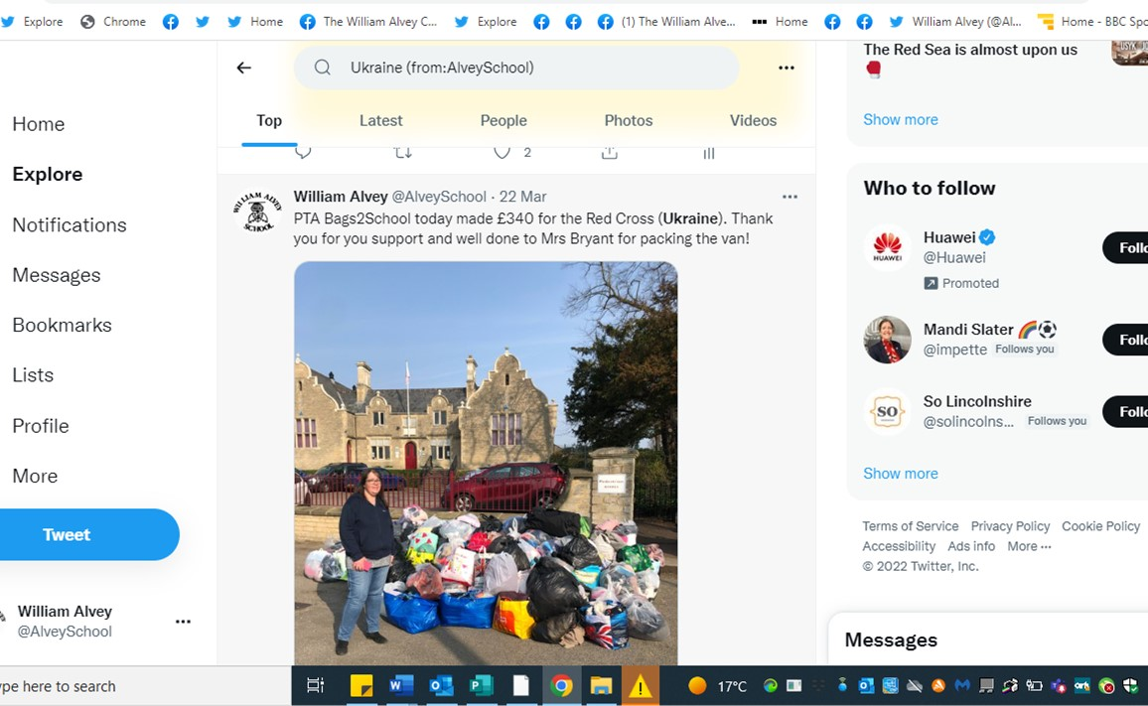

A non-uniform day:

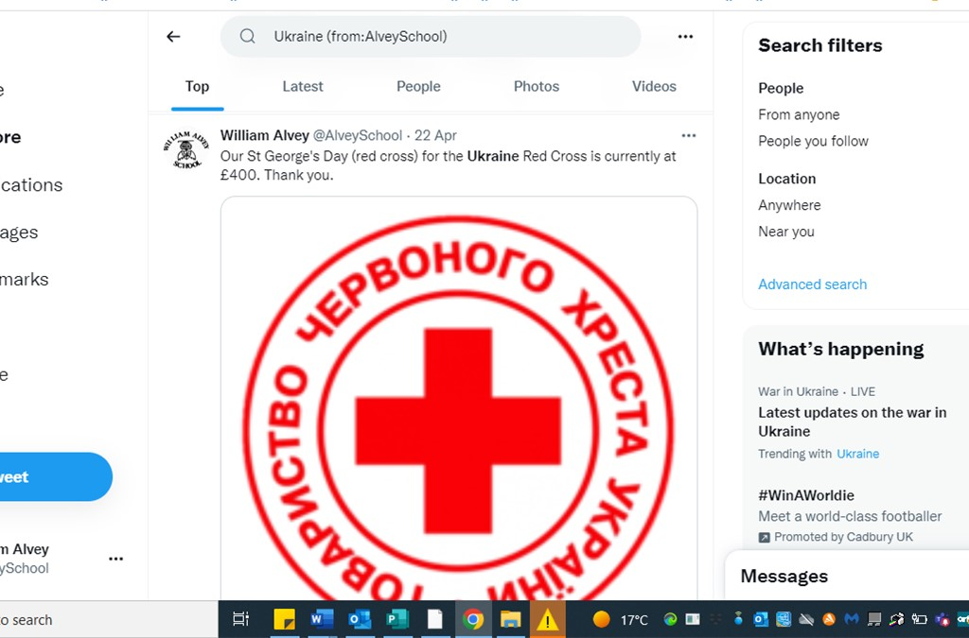

Jenny helped organise a cake sake run by a group of children in our Year 5:

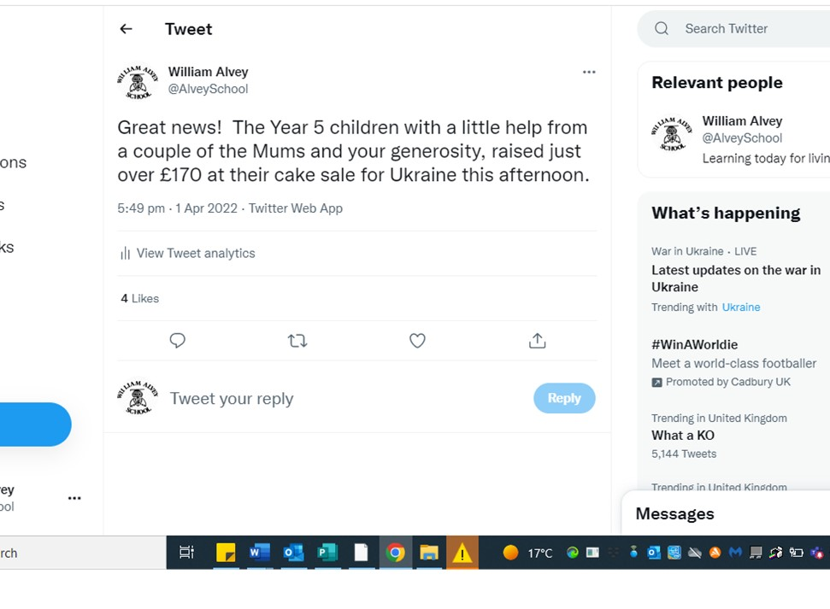

It inspired some of our children to do the same:

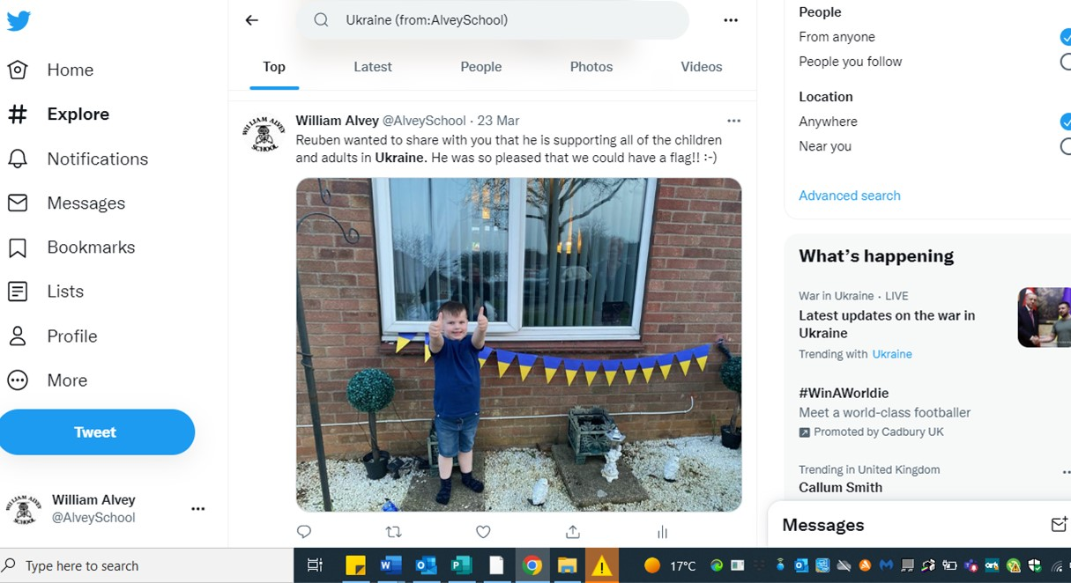

Jenny and the children raised enough money to help sponsor a bus:

