Dear parents and carers, 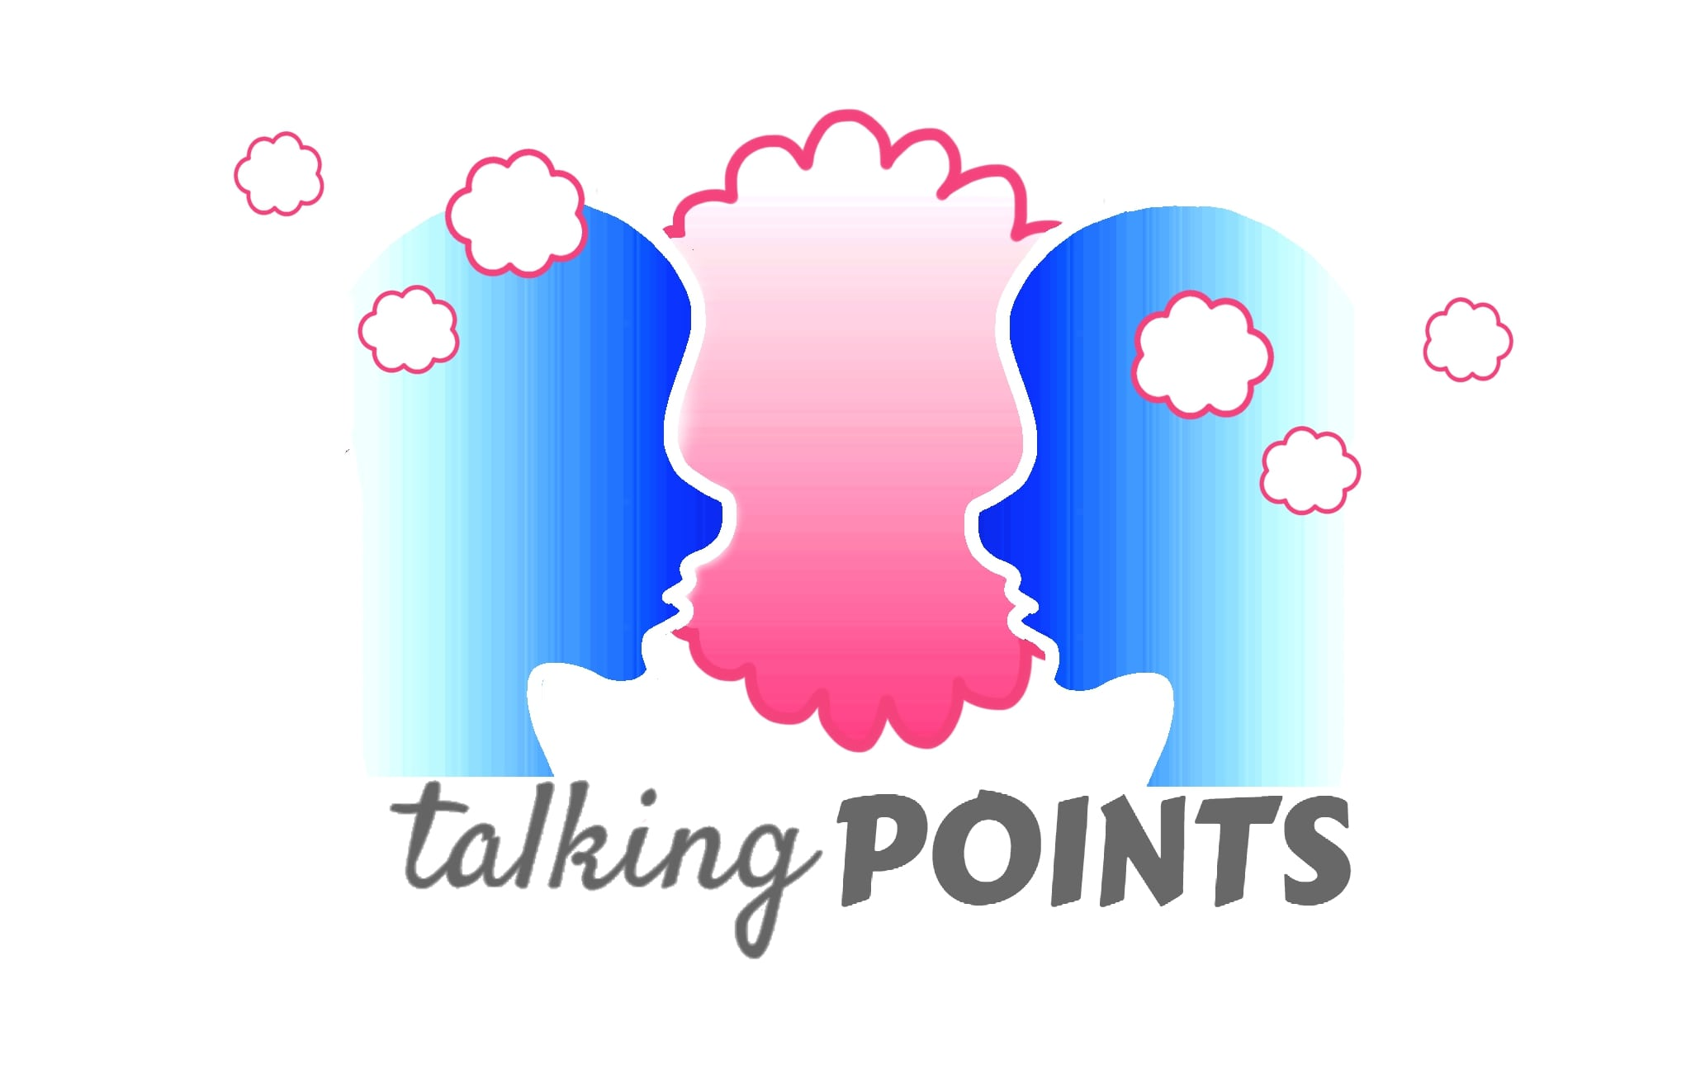
Our school is using the Talking Points schemes of work to deliver the government guidance on Health and Relationships education. It uses picture books as a starting point to get children talking about their own health and mental wellbeing as well as addressing other issues such as managing money and understanding democracy. Its aim is to develop children’s understanding of themselves, their emotions and how to deal with others. It also teaches children how to stay safe in many situations and who to speak to if they are ever worried or concerned.
Each two-week Talking Point unit has a question attached and they are listed below with the book that the children will read as a starting point.
 | Talking Point Question | Book | Author
1 | What’s that feeling I have? | The bear, the piano, the dog and the fiddle | David Litchfield
2 | What do I do when my friend is cross? | I hate everything | Sue Graves
3 | How do I compromise? | The squirrels who squabbled | Rachel Bright
4 | How do I do emergency first aid? | Charlie is broken | Lauren Child
5 | Am I at risk? | Mini Rabbit not lost | John Bond
6 | How do I stay safe online? | Chicken clicking | Jeanne Willis
7 | Am I safe on my mobile phone? | Elle gets a mobile phone | Nina Du Thaler
8 | What can I do about negative thoughts? | Your mind is like the sky | Bronwen Ballard
9 | Should I own up? | David gets in trouble | David Shannon
10 | Is it ok to hug? | Miles is the boss of his body | Samantha Kurtzman-Counter and Abbie Schiller
11 | What’s an aspiration? | Stardust | Jeanne Willis
12 | What is enterprise? | Ruby's wish | Sharin Yim Bridges
13 | What worries me in the world? | The king who banned the dark | Emily Howarth-Booth
14 | What is discrimination? | Along came a different | Tom McLaughlin
15 | What does it mean to be anti-social? | The bad seed | Jory John
16 | How do I support my community? | What can a citizen do? | Dave Eggers
17 | What’s a volunteer? | A Castle on Viola Street | Dyanne Disalvo
18 | Can I volunteer or help others? | The red bicycle | Jude Isabella

If you have any questions or concerns, please contact the school in writing.

Stephen.Tapley@william-alvey.lincs.sch.uk

Thank you for your continued support

