William Alvey Primary School
Freedom of Information Policy

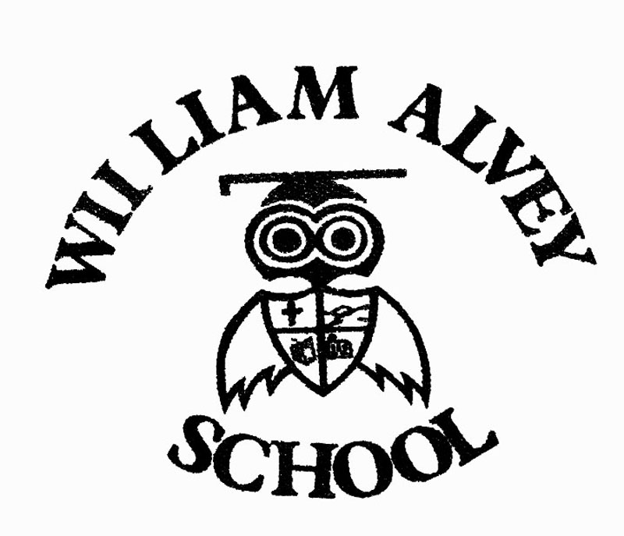

Aims & Objectives:

The aim of this policy is to provide a model set of guidelines to enable staff, parents and pupils to understand:
- The law regarding personal data
- How personal data should be processed, stored, archived and deleted/destroyed
- How staff, parents and pupils can access personal data

The objective of the policy is to ensure that the school acts within the requirements of the Data Protection Act 1998 when retaining and storing personal data, and when making it available to individuals, and that the process of responding to enquiries for other information is also legal under the Freedom of Information Act 2000 (in force from 1st January 2005).

Data Protection – the law:

Under the Data Protection Act 1998, and other regulating acts, access to their own personal information is a statutory right for pupils (if they are of an age to understand the information they request) and parents (as defined in the Education Act 1996) may also request access to their child’s personal data.

School staff have a right of access to personal data on themselves.

Anyone has the right to question and correct inaccurate information, but this must be matters of fact, not opinions.

Personal data should always be kept securely and protected by passwords if it is electronic, and access to it should only be by those authorised to see it – confidentiality should be respected. The law also provides that personal data should not be kept longer than is required.

Third party data (information about someone other than the requesting individual) should in general only be provided with their permission.

There should be a named person with overall responsibility for personal data within each school. In most cases this would be the Head Teacher.

Processing, storing, archiving and deleting personal data: guidance

- Personal data and school records about pupils are confidential to the child. The information can be shared appropriately within the professional working of the school to enable the school to make the best educational provision for the child. The law permits such information to be shared with other educational establishments when pupils change schools.
- School records for a child should be kept for 7 years after the child leaves the school, or until the child reaches 25 years of age (whichever is greater) and examination records the same.
- Data on staff is sensitive information and confidential to the individual, and is shared, where appropriate, at the discretion of the Head Teacher and with the knowledge, and if possible the agreement of the staff member concerned.
- Employment records form part of a staff member’s permanent record. Because there are specific legislative issues connected with these (salary and pension details etc.) these records should be retained as set out by the LEA.
- Interview records, CV’s and application forms for unsuccessful applicants are kept for 6 months.
- All formal complaints made to the Head Teacher or School Governors will be kept for at least seven years in confidential files, with any documents on the outcome of such complaints. Individuals concerned in such complaints may have access to such files subject to data protection and to legal professional privilege in the event of a court case.

Accessing personal data: guidance
- A child can request access to his/her own data. The request is not charged and does not have to be in writing. The staff will judge whether the request is in the child’s best interests, and that the child will understand the information provided. They may also wish to consider whether the request has been made under coercion.
- A parent can request access to or a copy of their child’s school records and other information held about their child. The request must be made in writing. There is no charge for such requests on behalf of the child, but there may be a charge for photocopying records – this is detailed in guidance available from the Information Commissioner. Staff should check, if a request for information is made by a parent, that no other legal obstruction (for example, a court order limiting an individual's exercise of parental responsibility) is in force.
- Parents should note that all rights under the Data Protection Act to do with information about their child rest with the child as soon as they are old enough to understand these rights. This will vary from one child to another, but, as a broad guide, it is reckoned that most children will have a sufficient understanding by the age of 12. Parents are encouraged to discuss and explain any request for information with their child if they are aged 12 or over.
- Separately from the Data Protection Act, The Education (Pupil Information)(England) Regulations 2005 provide a pupil’s parent (regardless of the age of the pupil) with the right to view, or to have a copy of, their child’s educational record at the school. Parents who wish to exercise this right must apply to the school in writing.
- For educational records (unlike other personal data; see below) access must be provided within 15 school days, and if copies are requested, these must be supplied within 15 school days of payment.
- A member of West Berkshire Council staff can request access to their own records at no charge, but the request must be made in writing. The member of staff has the right to see their own records, and to ask for copies of the records. There is no charge for copies of records.
- The law requires that all requests for personal information are dealt with within 40 days of receipt except requests for educational records (see above). All requests will be acknowledged in writing on receipt, and access to records will be arranged as soon as possible. If awaiting third party consents, the school will arrange access to those documents already available, and notify the individual that other documents may be made available later.
- In all cases, should third party information (information about another individual) be included in the information the staff will try to obtain permission to show this information to the applicant, with the exception of information provided by another member of school staff (or local authority staff) which is exempt from a requirement for third party consents. If third party permission is not obtained the person with overall responsibility should consider whether the information can still be released.
- Personal data should always be of direct relevance to the person requesting the information. A document discussing more general concerns may not be defined as personal data.
- From 1st January 2005, when the Freedom of Information Act came into force, a request for personal information can include unstructured as well as structured records – for example, letters, emails etc. not kept within an individual’s personal files, or filed by their name, but still directly relevant to them. If these would form part of a wider record it is advisable to file these within structured records as a matter of course and to avoid excessive administrative work. These can be requested if sufficient information is provided to identify them.
- Anyone who requests to see their personal data has the right to question the accuracy of matters of fact within the data, and to ask to have inaccurate information deleted or changed. They may also question opinions, and their comments will be recorded, but opinions do not need to be deleted or changed as a part of this process.
- The school will document all requests for personal information with details of who dealt with the request, what information was provided and when, and any outcomes (letter requesting changes etc.) This will enable staff to deal with a complaint if one is made in relation to the request.

Fair processing of personal data: data which may be shared

Schools, local education authorities and the Department for Education (DfE) all hold information on pupils in order to run the education system, and in doing so have to follow the Data Protection Act 1998. This means, among other things, that the data held about pupils must only be used for specific purposes allowed by law. The school has a Fair Processing or Privacy Notice which explains how personal data is used and with whom it will be shared. This Notice is published here: [website address]

The Local Education Authority uses information about pupils to carry out specific functions for which it is responsible, such as the assessment of any special educational needs the pupil may have. It also uses the information to derive statistics to inform decisions on (for example) the funding of schools, and to assess the performance of schools and set targets for them. The statistics are used in such a way that individual pupils cannot be identified from them.

Information on how to access personal data held by other organisations is given below.

Include the following paragraph if the school does NOT have secondary age pupils

Pupils, as data subjects, have certain rights under the Data Protection Act, including a general right of access to personal data held on them, with parents exercising this right on their behalf if they are too young to do so themselves. If parents want to request to access the personal data held about their child, they should contact the relevant organisation in writing:

- the school as above;
- the LEA’s Data Protection Officer at Information Management Officer, Strategic Support, Council Offices, Market Street, Newbury RG14 5LD;

Include the following paragraphs if the school has secondary age pupils

Pupils, as data subjects, have certain rights under the Data Protection Act, including a general right of access to personal data held on them, with parents exercising this right on their behalf if they are too young to do so themselves. If your child wishes to access their personal data, or you wish to do so on their behalf, then please contact the relevant organisation in writing:

- the school as above;
- the LEA’s Data Protection Officer at Information Management Officer, Strategic Support, Council Offices, Market Street, Newbury RG14 5LD;

Access to other school information – guidance on Freedom of Information

Publication Schemes

- Under the Freedom of Information Act 2000, all schools (primary, secondary and nursery) should have a ‘publication scheme’ – essentially a formal list of the types of non-personal information which the school produces or holds, and which is readily accessible to staff, pupils and parents or other enquirers.
- The publication scheme should be available as a hard copy and also posted on the website (if the school has one). The model scheme supplied by the Information Commissioner’s Office should have been adopted from January 2009.
- Schools can link this document via their website to a list of publications with details of contacts and costs, and any appropriate downloads.
- There should be a named person with overall responsibility for published information within each school. In most cases this would be the Head Teacher.

Requests for information

- The Freedom of Information Act came into force on 1st January 2005. Under this Act, all schools which receive a written or emailed request for information which they hold or publish, are required to respond within 20 working days.
- The school will provide information on where to access the information required eg. the website link, or details of a charge if the publication/ information is charged, or send any free information. If the item is charged the school does not need to provide it until the payment is received.
- A refusal of any information requested must state the relevant exemption which has been applied or that the school does not hold the information, and must explain what public interest test has made if this applies.
- If the information is published by another organisation (for example, Ofsted reports, DCSF leaflets) the school can direct the enquirer to the organisation which supplied the information or publication unless it is legal and possible to provide the information direct (for example, a copy of the summary of an Ofsted report, spare copies of a DCSF leaflet ).
- It will not be legal to photocopy a publication in its entirety and supply this to an enquirer unless the school owns the copyright – this is particularly important where the original publication was a charged item.
- The school will keep the original request and note against this who dealt with the request and when the information was provided.
- Any complaint about the provision of information will be handled by the Head Teacher or another senior member of staff. All complaints should be in writing and documented. The Publication Scheme will include information on who to contact for both enquiries and complaints.
- All enquirers should be advised that they may complain to the information Commissioner if they are unhappy with the way their request has been handled.

Reviewing:
This guide and policy will be reviewed, and updated if necessary every two years. The Freedom of Information publication scheme should be reviewed regularly, with staff checking if they add a new piece of recorded information to the school’s portfolio that this is covered within the scheme.

Bibliography:

Criminal Records Bureau: Code of Practice and explanatory guide for registered persons and other recipients of disclosure information: Guidance on retention of CRB checks and other information. www.crb.gov.uk/downloads/code_of_practice_and_explanatory_guide.pdf

Data Protection Act 1998: All personal data which is held must be processed and retained in accordance with the eight principles of the Act and with the rights of the individual. Personal data must not be kept longer than is necessary (this may be affected by the requirements of other Acts in relation to financial data or personal data disclosed to Government departments). Retention of personal data must take account of the Act, and personal data must be disposed of as confidential waste. Covers both personal data relating to employees and to members of the public.

Data Protection Act 1998: Compliance Advice. Subject access – Right of access to education records in England: General information note from the Information Commissioner on access to education records. Includes timescale (15 days) and photocopy costs.

Data Protection Act 1998: Compliance Advice. Disclosure of examination results by schools to the media: General information note from the Information Commissioner on publication of examination results.

Education Act 1996: Section 509 covers retention of home to school transport appeal papers. (By LEA)

Education (Pupil Information) (England) Regulations 2005: Retention of Pupil records

Guidance to LEAS: Requirements with respect to “fair processing” under the data protection act and the passing of information to connexions. 2005 DfES: Guidance Note

Health and Safety at Work Act 1974 & Health and Safety at Work Act 1972: Retention requirements for a range of health and safety documentation including accident books, H&S manuals etc.

Information Commissioner’s Code of Practice Guidelines (ICC of P Guidelines): available on the internet www.ico.gov.uk Guidance on retention of interview and employment records

Personnel Files – Guidance Note for Schools. 2003. West Berkshire Council: Retention of personnel files

Recruitment checks – safeguarding our children in West Berkshire Schools. 2002. West Berkshire Council: Guidance on retention of recruitment checks

School Standards and Framework Act 1998: Retention of school admission and exclusion appeal papers and other pupil records.

Information and Records Management Society – Schools records management toolkit
http://www.irms.org.uk/resources/information-guides/199-rm-toolkit-for-school
A downloadable schedule for all records management in schools

