Wiliam Alvey School
Uniform Policy

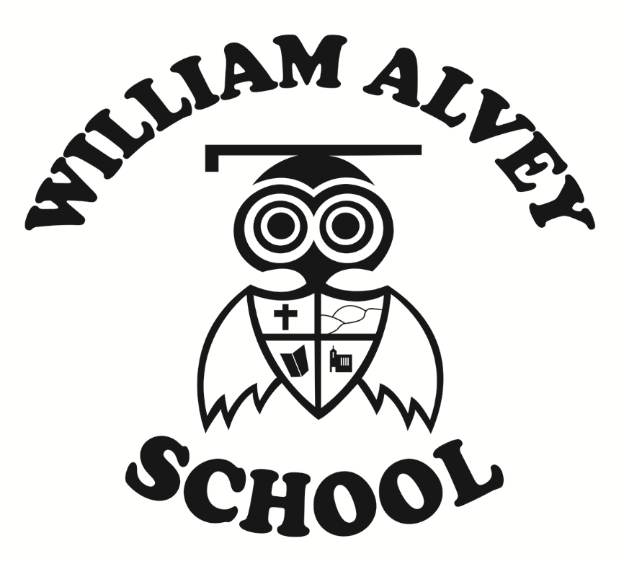

1. Aims
This policy aims to:
- Set out our approach to requiring a uniform that is of reasonable cost and offers the best value for money for parents and carers
- Explain how we will avoid discrimination in line with our legal duties under the Equality Act 2010
- Clarify our expectations for school uniform

2. Our school’s legal duties under the Equality Act 2010
The Equality Act 2010 prohibits discrimination against an individual based on the protected characteristics, which include sex, race, religion or belief, and gender reassignment.
To avoid discrimination, our school will:
- Avoid listing uniform items based on sex, to give all pupils the opportunity to wear the uniform they feel most comfortable in or that most reflects their self-identified gender
- Make sure that our uniform costs the same for all pupils
- Allow all pupils to have long hair (though we reserve the right to ask for this to be tied back)
- Allow all pupils to style their hair in the way that is appropriate for school yet makes them feel most comfortable
- Allow pupils to request changes to swimwear for religious reasons
- Allow pupils to wear headscarves and other religious or cultural symbols

3. Limiting the cost of school uniform
Our school has a duty to make sure that the uniform we require is affordable, in line with statutory guidance from the Department for Education on the cost of school uniform.
We understand that items with distinctive characteristics (such as branded items, or items that have to have a school logo or a unique fabric/colour/design) cannot be purchased from a wide range of retailers and that requiring many such items limits parents’ ability to ‘shop around’ for a low price.
We will make sure our uniform:
- Is available at a reasonable cost
- Provides the best value for money for parents/carers
We will do this by:
- Limiting any items with distinctive characteristics where possible
- Avoiding specific requirements for items pupils could wear on non-school days, such as coats, bags and shoes
- Avoiding different uniform requirements for different year groups or classes
- Avoiding different uniform requirements for extra-curricular activities
- Making sure that arrangements are in place for parents to acquire second-hand uniform items
- Avoiding frequent changes to uniform specifications and minimising the financial impact on parents of any changes
- Consulting with parents and pupils on any proposed significant changes to the uniform policy and carefully considering any complaints about the policy

4. Expectations for school uniform
4.1 Our school’s uniform

School uniform is important to us and we insist upon it. We have highlighted, in black, the 'branded' items and their cost from the least expensive provider:

Black shoes (not trainers or shoes with a white sole)
Dark grey trousers
Grey skirt
Grey socks/tights
Light blue shirt with collar
Burgundy jumper with owl logo (from £12.99)
Light blue gingham dress (summer)
Winter coat (please no hoddies, or overtly branded sportswear)
You have the option of a elasticated tie (from £2.99), a knotted tie (from £3.99) and a clip on tie (from £4.99)

PE Kit Indoor
Black/navy shorts
House t-shirt (from £5.00). Please contact the office for house colours.
Plimsols or trainers

PE Kit Outdoor
Black/navy shorts
House t-shirt (contact the office for house colours)
Trainers (suitable for grass or 3G-astro surface)
Track suit/sweat-shirt when cold.

You can buy the school uniform (jumper, tie and House t-shirt) from:

1. SJB Uniforms, 2 Market Street, Sleaford NG34 7SF ring 01529 400429 https://sjb-uniforms.co.uk/

2. Uniform Direct or visit their shop, Dixon House, Dixon Way, Lincoln, Lincolnshire, LN6 7XN. Email: customerservices@uniform-direct.com or ring 01522 510016.
You can buy the rest of the uniform (blue shirt, grey trousers and grey skirt) from other outlets:

ASDA/TESCO/SAINSBURYS.

We do have a second-hand shop which we run from school where we sell recycled uniform (all uniform is between 50p to £2.00). We also run a shoe swap shop. We do not want the cost of our uniform to prevent any parent or child from choosing our school and we do offer a yearly £20 discount on school uniform for any child on income based free school meals (please provide receipts to claim a reimbursement). Children will require a swimming kit in KS2. Sleaford leisure centre have their own requirements for swimming kit and we follow their standard operating procedures.

We don’t encourage jewellery in school, small stud earrings and small signet rings are acceptable but we would ask that the children learn how to remove earrings for PE. Jewellery worn for religious or medical reasons will of course be considered in light of our inclusion policy. No extreme haircuts or unnaturally coloured hair. Hair styles based on religious, cultural or ethnicity will of course be considered in line with our inclusion policy and all current legal requirements.

There are no restrictions in terms of a school bag, the only limiting factor is the size of the school lockers.

Please e-mail me at head.teacher@william-alvey.lincs.sch.uk if you need any extra help or advice regarding our uniform.

5. Expectations for our school community
5.1 Pupils
Pupils are expected to wear the correct uniform at all times (other than specified non-school uniform days) while:
- On the school premises
- Travelling to and from school
- At out-of-school events or on trips that are organised by the school, or where they are representing the school (if required)
5.2 Parents and carers
Parents and carers are expected to make sure their child has the correct uniform and PE kit, and that every item is:
- Clean
- Clearly labelled with the child’s name
- In good condition
Parents are also expected to contact the Headteacher if they want to request an amendment to the uniform policy in relation to:
- Their child’s protected characteristics
- The cost of the uniform
Parents are expected to lodge any complaints or objections relating to the school uniform in a timely and reasonable manner.
Disputes about the cost of the school uniform will be:
- Resolved locally
- Dealt with in accordance with our school’s complaints policy
The school will work closely with parents to arrive at a mutually acceptable outcome.
5.3 Staff
Staff will closely monitor pupils to make sure they are in correct uniform. They will give any pupils and families breaching the uniform policy the opportunity to comply, but will follow up with the headteacher if the situation doesn’t improve.
In cases where it is suspected that financial hardship has resulted in a pupil not complying with this uniform policy, staff will take a mindful and considerate approach to resolving the situation.
5.4 Governors
The governing board will review this policy and make sure that it:
- Is appropriate for our school’s context
- Is implemented fairly across the school
- Takes into account the views of parents and pupils
- Offers a uniform that is appropriate, practical and safe for all pupils
The board will also make sure that the school’s uniform supplier arrangements give the highest priority to cost and value for money, for example by avoiding single supplier contracts and by re-tendering contracts at least every 5 years.

6. Monitoring arrangements
This policy will be reviewed as part of the non-curriculum review cycle.

7. Links to other policies
This policy is linked to our:
- Behaviour policy
- Equality information and objectives statement
- Anti-bullying policy
- Complaints policy

