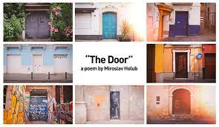
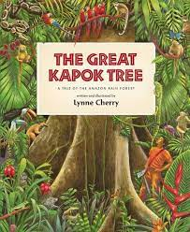
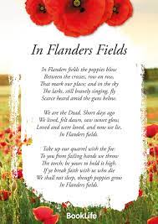
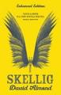

Talk for Reading

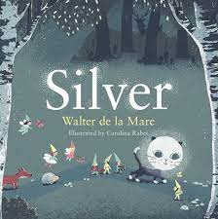
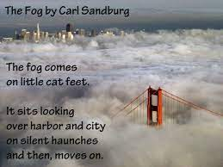


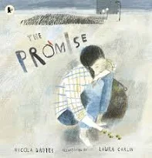

Maths
- Autumn 1 – Place value
Addition and Subtraction
- Autumn 2 – Multiplication and Division
Statistics
- Spring 1 – Fractions
- Spring 2 – Decimals
Percentages
- Summer 1 – Geometry
- Summer 2 – Perimeter and area
Volume
Roman numerals

Science
- Throughout the year – Working scientifically
- Autumn 1 – Properties of Materials
- Autumn 2 – Earth and Space
- Spring 1 – Properties of materials
- Spring 2 – Forces
- Summer 1 – Living things and their habitats
- Summer 2 – Animals including humans
Talk for Writing
- Autumn 1 – Atmosphere and suspense openings
- Autumn 2 – Discussion and Poetry
- Spring 1 – Action
- Spring 2 – Characterisation
- Summer 1 – Information text and non-chronological reports
- Summer 2 – Meeting Tale

RE
- Autumn 1 – Being Human and Hinduism- Believing
- Autumn 2 – Being Human and Islam- Believing
- Spring 1 – Being Human and Christianity- Believing
- Spring 2 – Being Human and Christianity- Believing
- Summer 1 – Big questions
- Summer 2 – What does it mean to live a good life?

Geography
- Autumn –
- Spring – Geography Skills(1)
Coasts (2)
- Summer – The Environment formatioenvironmentalism

Year 5

PE
- Autumn 1 – Invasion games and gymnastics
- Autumn 2 – Invasion games, and Fitness
- Spring 1 – Dance and invasion games
- Spring 2 – Dance and invasion games.
- Summer 1 – Striking and fielding and gymnsatics
- Summer 2 – Athletics and gymnastics

Design Technology
- Autumn 2 – Making bread
- Summer 1 – Cams

Computing
- Autumn – Systems (1) Videoing (2)
- Spring – Coding/Programming (1) Databases (2)
- Summer – Vector Graphics (1) Coding/Programming (2)
Music
- Autumn 1 – Changra Unit, Ballads, recorders and appraising composers
- Autumn 2 – Kapow Unit Space. Composing music using garage band and appraising composers
- Spring 1 and 2– Glockenspiels and reading music. Composing music using garage band. and appraising composers
- Summer 1 – Playing the ukulele and appraising composers
- Summer 2 – Playing the ukulele. Performing to an audience and playing by ear. Composing sea shanties and appraising composers

French
- Autumn – Body Portraits, Describing monsters, adjectival agreement.
- Spring –
- Summer – Food and shopping, numbers to 100, French Breakfast.
History
- Autumn 1 – The Roman Empire
- Autumn 2 – The History of Space travel
- Spring 1 - The Anglo-Saxons

Art
- Autumn 1 – Art Nouveau
- Spring 1 –
- Summer 2 – Wire sculpture (1)
Textiles (2)

