Year 4 Literacy Homework Autumn 2 2025
Here is a list of the homework tasks that the children should complete each week. Please ensure that your child hands in their book for marking on Monday of each week, and their teacher will ensure that it is given back by Thursday for the next task. We encourage the children to take pride in their work and expect their homework book to be as wonderfully presented as their book in school. Children should complete their homework in pencil unless they use a fountain pen in school.

Week 1: Handed out 3.11.25 to be handed in by 6.11.25

Must: Complete ‘The Gunpowder Plot’ reading comprehension.

Could – Get creative and make your own bonfire night artwork.

Week 2: Handed out 10.11.25 to be handed in by 13.11.25
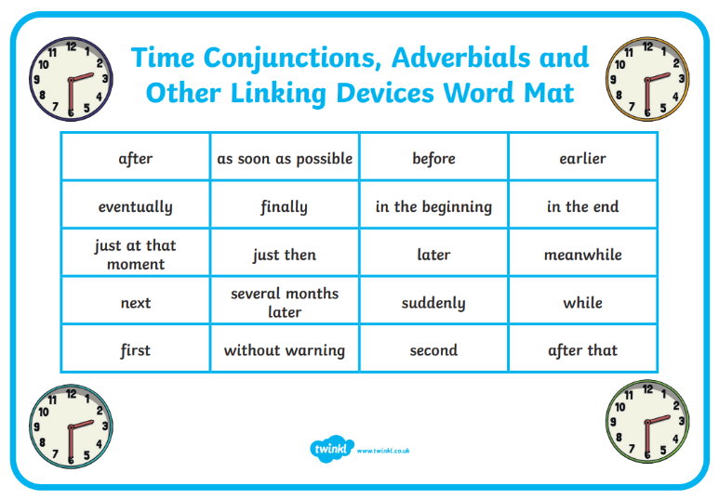

Must – Write 5 sentences using a different time conjunction in each. Choose them from this word mat.

Could – write a short story using your chosen conjunctions.
Week 3 & 4: Handed out 17.11.25 to be handed in by 27.11.25

Must- In school, we have been learning about Courageous Advocacy – the act of speaking out against an issue of injustice, often on behalf of those whose voice is not heard.
We have been learning about Chico Mendes and his courageous work.

We would like you to choose your own courageous advocate to research and tell us who they are and what impact they have had. Some suggestions could be: Marcus Rashford, David Attenborough, Martin Luther King, Nelson Mandela, Malala Yousafzai, Princess Diana.

This is a two week project so please present your work creatively with as much detail as possible.
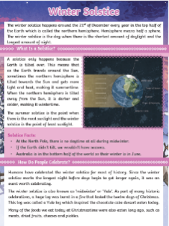
Week 5: Handed out 1.12.25 to be handed in by 4.12.25

Must – Carefully read the text, The Winter Solstice, which has been stuck into your homework book. Then answer the questions relating to the text. Remember to answer in full sentences.
Week 6: Handed out 08.12.25 to be handed in by 11.12.24

Must – Design and make a Christmas card for someone who would really appreciate it. This might be your neighbour, elderly relative

Could: Christmas holidays promise
Try to complete 5 acts of kindness over the two-week break. This could be as simple as helping with the washing up or picking up litter.

