Year 4 Literacy Homework Autumn 1 2026
Here is a list of the homework tasks that the children should complete each week. Please ensure that your child hands in their book for marking on or before Thursday of each week, and their teacher will ensure that it is given back by Monday for the next task. We encourage the children to take pride in their work and expect their homework book to be as wonderfully presented as their book in school. Children should complete their homework in pencil unless they use a fountain pen in school.
We will be sending home spellings to learn this year and we have attached the Year 3/4 word list – these are the words the children are expected to read and spell by the end of Year 4. Please practise these with your child as often as they can.
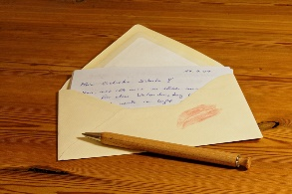
Week 1: Handed out 07.09.26 to be handed in by 10.09.26

Must - Write a letter to your teacher telling them how you are feeling about being in Year 4. You could tell them what it is like being back at school, what you are looking forward to or anything that may be worrying you. Challenge yourself to include some of the things we have learnt so far as well as using some of the Year 3/4 spelling words.

Could – Consider how to present your letter so it looks attractive. Make sure you include your best handwriting if you choose to write it by hand.
Week 2: Handed out 14.09.26 to be handed in by 17.09.26

Must – Complete the colour by word classes sheet (beetle). Follow the instructions on the sheet to colour in the nouns, verbs, adjectives and adverbs. We have been learning these in class.
Could – Write 5 sentences which include the 4 word classes listed and colour code them yourself.
Eg. The brown, fluffy dog ran quickly. Noun Verb Adjective Adverb
Week 3: Handed out 21.09.26 to be handed in by 24.09.26

Must – Complete the reading comprehension sheet – Living things and their habitats
Could – If there are any words you are unsure of, look up the meaning of them in a dictionary.

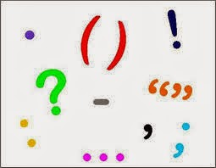
Week 4: Handed out 28.09.26 to be handed in by 01.10.26

Must – Complete the ‘Correct the sentence’ sheet. Write the sentences correctly and neatly on the sheet in your book.
Could – Make a punctuation poster or leaflet explaining when and how you should use capital letters, full stops, question marks and exclamation marks. You could even challenge yourself to include speech marks and apostrophes if you are feeling confident.
Week 5: Handed out 05.10.26 to be handed in by 08.10.26

Must – Choose an animal and draw a picture of it and label it. Research and describe its habitat.
Could - Present this in a creative way – you could make a model of your animal or a powerpoint.
Week 6: Handed out 12.10.26 to be handed in by 15.10.26
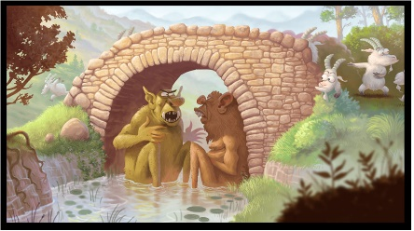
Must – Write the speech conversation that these two characters might be having. Remember to punctuate it correctly.
- New speaker, new line.
- Speech marks around the words spoken
- A capital letter for the first word inside the speech marks.
- Punctuation to separate who is speaking from what they are saying, eg. a comma.
Week 7: Handed out 19.10.26 to be handed in by 22.10.26

Must – Complete the reading comprehension sheet – All about wolves
Could – If there are any words you are unsure of, look up the meaning of them in a dictionary.

