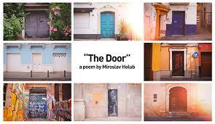
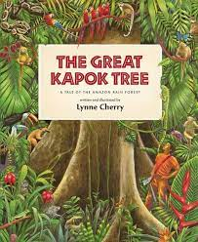
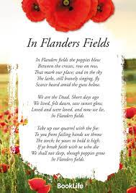
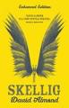
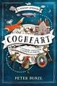
Talk for Reading

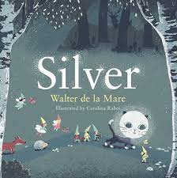
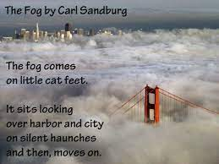


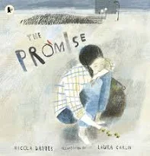

Maths
- Autumn 1 – Place value
Addition and Subtraction
- Autumn 2 – Multiplication and Division
Statistics
- Spring 1 – Fractions
- Spring 2 – Decimals
Percentages
- Summer 1 – Geometry
- Summer 2 – Perimeter and area
Volume
Roman numerals

Science
- Autumn 1 – Properties of Materials
- Autumn 2 – Forces
- Spring 1 – Earth and Space
- Spring 2 –
- Summer 1 – Animals including humans
- Summer 2 – Living things and their habitats
Talk for Writing
- Autumn 1 – Information texts
- Autumn 2 – Suspense
- Spring 1 – Action
- Spring 2 – Meeting Tale
- Summer 1 – Discussion and Poetry
- Summer 2 – Characterisation

RE
- Autumn 1 Does creativity matter in religious world-views? (Music)
- Autumn 2 – Does creativity matter in religious world-views? (Art)
- Spring 1 – Do people always put their beliefs into action? (Christian worldviews)
- Spring 2 – Do people always put their beliefs into action? (Muslim worldviews)
- Summer 1 – Are all people equal? (Sikh worldviews)
- Summer 2 – Are all people equal? (Christian and non-religious

Geography
- Autumn
- Spring 2 – Environment
- Summer 1 – Geography skills
- Summer 2 - Coasts

Year 5

PE
- Autumn 1 Swimming, Yoga
- Autumn 2 – Invasion games and Yoga
- Spring 1 – Invasion games and Gymnastics
- Spring 2 – Cricket and Gymnastics
- Summer 1 – Tennis and Dance,
- Summer 2 – Athletics and Dance

Design Technology
- Autumn 2 – Making bread
- Spring 1 – Cams

Computing
- Autumn – Systems (1) Videoing (2)
- Spring – Coding/Programming (1) Databases (2)
- Summer – Vector Graphics (1) Coding/Programming (2)
Music
- Autumn 1 – Changra Unit, Ballads, recorders and appraising composers
- Autumn 2 – Kapow Unit Space. Composing music using garage band and appraising composers
- Spring 1 and 2– Glockenspiels and reading music. Composing music using garage band. and appraising composers
- Summer 1 – Playing the ukulele and appraising composers
- Summer 2 – Playing the ukulele. Performing to an audience and playing by ear. Composing sea shanties and appraising composers

French
- Autumn – Body Portraits, Describing monsters, adjectival agreement.
- Spring –
- Summer – Food and shopping, numbers to 100, French Breakfast.
History
- Autumn 1 – The Roman Empire
- Autumn 2 – The Anglo-Saxons
- Spring 1 - The History of Space travel

Art
- Autumn 1 – Art Nouveau
- Spring 2 – Wire sculpture
- Summer 2 – Architecture

