William Alvey Primary School
Supporting Adopted Children and their Families

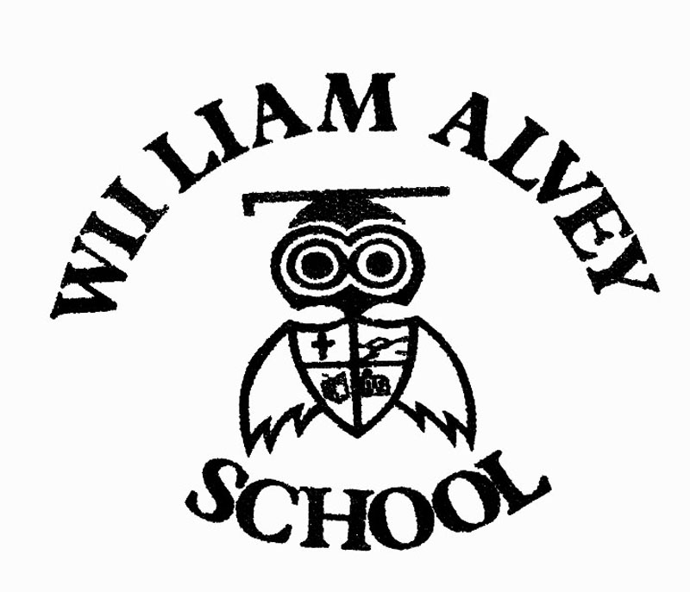
At The William Alvey School, we recognise that adoption has lifelong implications for all involved and requires commitment from many different organisations, professionals and individuals who must work together to meet the needs of those affected by adoption. We believe that :

‘Adopted children should have an enjoyable childhood, and benefit from excellent parenting and education, enjoying a wide range of opportunities to develop their talents and skills, which in turn will lead to a successful adult life’. (Adoption National Minimum Standards 2011).

We recognise the importance of having clear structure, policy and procedures in place to assist in welcoming adopted children (and those children under Special Guardianship Arrangements) into our school.

Our aims to support adopted children

- On admission, we will ensure that parents have the name of the Designated Leader for adopted children (also known as Adopted Children’s Champion) and their contact details, a copy of the school’s policy on supported adopted children and a list of any additional support programmes currently offered in school.

- We will strive to provide a safe and secure environment, which values education and believes in the abilities and potential of all children.

- Through promoting and supporting the education of our adopted children, we will ensure equality in the educational attainments of our adopted children and their peers, making sure that they have access to education appropriate to their age and ability. This includes access to a broad and balanced curriculum.

- We will ensure that adopted children and their families are supported educationally, emotionally and socially.

- All staff and governors are committed to improving educational life chances for adopted children by ensuring that the relevant staff have reasonable support and time to complete tasks and responsibilities.

The designated teacher (Adopted Children’s Champion)

The Designated Leader for adopted children (Adopted Children’s Champion) will act as their advocate and co-ordinate support for them, liaising with adoptive parents and outside agencies (as appropriate) on a wide variety of educational and support issues. They will ensure all Pupil Premium Grant funding received for the support of adopted and looked after children is appropriately spent and the impact of the expenditure is measured as we believe this is a key element to providing better more focused support.

In addition their role is to:

- Review long term plans with the class teacher and the family to identify any potentially sensitive areas e.g. the ‘ourselves’ topic to consider how best to approach the topic with regard to the individual child’s circumstances (To be carried out in the June planning INSET day).

- Ensure that the class teacher is kept informed about any issues or difficulties that the child may be experiencing at home as well as ensuring that the family is kept informed about what might be going on for the child at school, for example, with peers, in the playground, friendship groups etc. where such communication is not already made directly between class teacher and family.

- Ensure that the Family have contact details of the designated teacher.

- Offer termly support meetings for parents of adopted children.

- To ensure that all staff (teaching and non-teaching) are adequately trained on issues affecting adopted children and their families (in conjunction with existing SEND training delivered by SENDCO)

- Offer at least annual training of all staff on strategies for support and transition arrangements for adopted children (In conjunction with SENDCO).

Admissions and Transitions

Adopted children share many characteristics with their non-adopted peers. However in common with other children who have experiences that have precipitated them coming into care, and prevented return to their family of origin, they can suffer from a similar range of emotional and behavioural difficulties. Transitions and change can prove a particularly challenging time. As a consequence, we will :

- Ensure that on admission or transfer all relevant information is obtained at the outset, (when an adoption has been made known to the school).

- Forward appropriate documents, in a timely fashion, to any receiving school at point of transition where the receiving school is made known.

- Make every effort to provide continuity of schooling and educational experience between year groups and/or any other receiving school.

- Ensure internal transition (such as moving up year groups in September) is managed in a timely and planned manner.

- Transition meetings will take place in July ensuring all information is shared with the receiving teacher – plans are in place & strategies agreed.

- The child is fully aware of the transition arrangements and who they can talk to if they are anxious or concerned (so the child is fully prepared before the summer break)

