Policy for managing serial and unreasonable complaints
William Alvey School

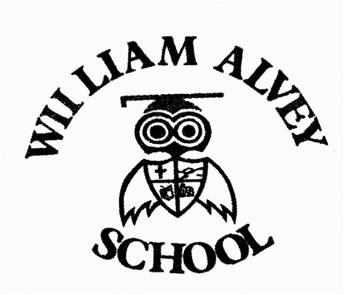

- William Alvey is committed to dealing with all complaints fairly and impartially, and to providing a high quality service to those who complain. We will not normally limit the contact complainants have with our school. However, we do not expect our staff to tolerate unacceptable behaviour and will take action to protect staff from that behaviour, including that which is abusive, offensive or threatening.
- William Alvey defines unreasonable behaviour as that which hinders our consideration of complaints because of the frequency or nature of the complainant’s contact with the school, such as, if the complainant:
- refuses to articulate their complaint or specify the grounds of a complaint or the outcomes sought by raising the complaint, despite offers of assistance
- refuses to co-operate with the complaints investigation process
- refuses to accept that certain issues are not within the scope of the complaints procedure
- insists on the complaint being dealt with in ways which are incompatible with the complaints procedure or with good practice
- introduces trivial or irrelevant information which they expect to be taken into account and commented on
- raises large numbers of detailed but unimportant questions, and insists they are fully answered, often immediately and to their own timescales
- makes unjustified complaints about staff who are trying to deal with the issues, and seeks to have them replaced
- changes the basis of the complaint as the investigation proceeds
- repeatedly makes the same complaint (despite previous investigations or responses concluding that the complaint is groundless or has been addressed)
- refuses to accept the findings of the investigation into that complaint where the school’s complaint procedure has been fully and properly implemented and completed including referral to the Department for Education
- seeks an unrealistic outcome
- makes excessive demands on school time by frequent, lengthy and complicated contact with staff regarding the complaint in person, in writing, by email and by telephone while the complaint is being dealt with
- uses threats to intimidate
- uses abusive, offensive or discriminatory language or violence
- knowingly provides falsified information
- publishes unacceptable information on social media or other public forums.
- Complainants should try to limit their communication with the school that relates to their complaint, while the complaint is being progressed. It is not helpful if repeated correspondence is sent (either by letter, phone, email or text), as it could delay the outcome being reached.
- Whenever possible, the headteacher or Chair of Governors will discuss any concerns with the complainant informally before applying an ‘unreasonable’ marking.
- If the behaviour continues, the headteacher will write to the complainant explaining that their behaviour is unreasonable and ask them to change it. For complainants who excessively contact William Alvey causing a significant level of disruption, we may specify methods of communication and limit the number of contacts in a communication plan. This will be reviewed after six months.
- In response to any serious incident of aggression or violence, we will immediately inform the police and communicate our actions in writing. This may include barring an individual from William Alvey.

The policy will be reviewed as part of the non curriculum review cycle.

